First Pitch (90 seconds)

Obtaining inspiration from popular family game *Connect 4* and *Gobang as* we all know, we came up our Game called Color Bingo, it has similar rule with Gobang: two players compete with each other, to have the same color 4 lined in row, column or Diagon in a grid. Here I’ll show you how does it work:

Lauch the file and we see the Start Menu. Here we see three buttons: Start Game, Game History and Rule Customize:

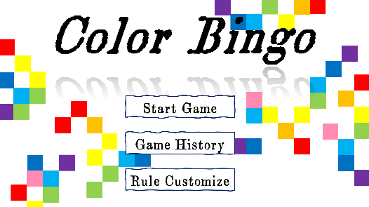

Click on the Start Game button and we see a grid with multiple squares but no item is applied, so it’s just a normal Gobang game now:

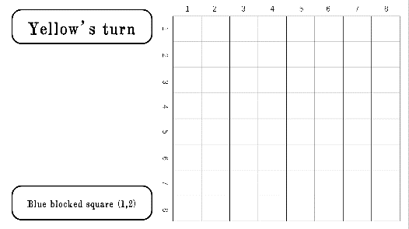

Let’s go back to Start Menu Page:



Now click on the Rule Customize button and see what we can do with it:

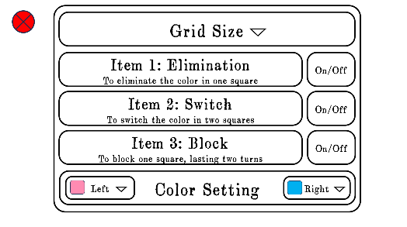

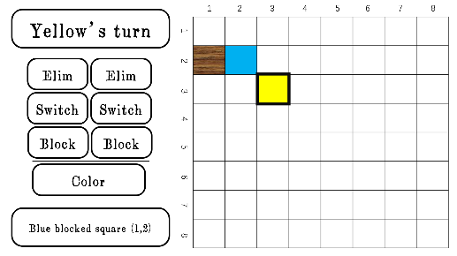In this page, we could customize the size of the grid, the color for each player, and the items will be applied later in the game; we save the rule settings and go back to start a new game:

We can see the gird size is what we set and applied items here. We also have a line here indicating whose turn it is. And a line below shows action history, so that players won’t forget last action their opponent did while considering next step.

For each action for each player, Color Bingo only allows either an item or coloring a square, after using either of them, one’s turn ends. The winning rule is to have the same color 4 lined in row, column or diagon.

After anyone wins, we could go back to the Start Menu to check game history, here we can see which color wined:

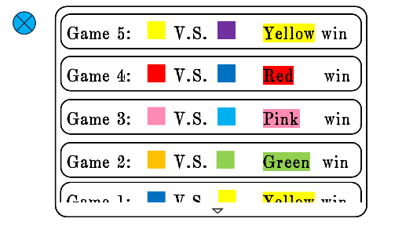

We may or may not add more details here later, for instance, analyzing action history for each game and come up with the best solution to win Color Bingo.

That’s all.